**IMAGE PREDICTION**

**Project Synopsis**

MAJOR PROJECT(ICI651)

Degree

**BACHELOR OF COMPUTER APPLICATION**

(CLOUD TECHNOLOGY & INFORMATION SECURITY**)**

| PROJECT GUIDE:  **Mr. Aditya Tripathi** | SUBMITTED BY:  **Abhishek Kumar Shukla (TCA2056004)**  **Deeksha Agarwal(TCA2056008)**  **Goldi Diwaker (TCA2056011)**  **Nomaan Khan(TCA2056016)** |
| --- | --- |

February, 2023



**FACULTY OF ENGINEERING & COMPUTING SCIENCES**

**TEERTHANKER MAHAVEER UNIVERSITY, MORADABAD**

Table of Contents

TITLE PAGE NO.

1 Project Title 3

2 Problem Statement 3

3 Project Description 3

3.1 Scope of the Work 3

4 Implementation Methodology 3

5 Technologies to be used 4

5.1 Software Platform 4

5.2 Hardware Platform 5

6 Advantages of this Project 5

7 Team Details 5

8 Conclusion 6

9  References 6

# 1.Project Title

The project title is “**Image predicition** ”.

The aim of this project is that you can easily find the name of the person or the object by just uploading a photo of that person or object.

# 2. Problem Statement

The main objective of this project to create an easy way to find the names of the objects and person. It is very easy to use and very helpful for the peoples to find the details.

# 3. Project Description

Image prediction is the process of using machine learning algorithms to analyze an image and predict what is contained within it. This can include predicting the presence of specific objects, people, or other features within the image.Image prediction is one of the major project by the help of which we can find the details of the objects and persons. It is also used by the CBI and Police to find the criminal but they can find that only details which is stored in their database and in this project we make them globally by the help of which we can find any person or any object details in this project.

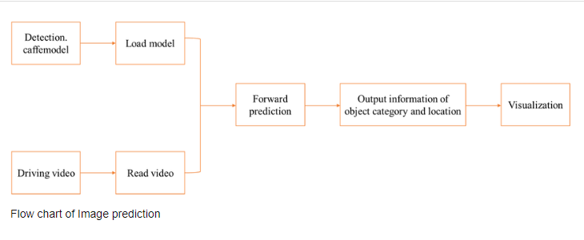

**CONTEXT DIAGRAM**

## 1.1 Scope of the Work

The future of image prediction will involve scanning the heavens for other intelligent life out in space. Also new intelligent, digital species created entirely by research scientists in various nations of the world will include advances in image processing applications. Due to advances in image processing and related technologies there will be millions and millions of robots in the world in a few decades time, transforming the way the world is managed.

# 4.Implementation Methodology

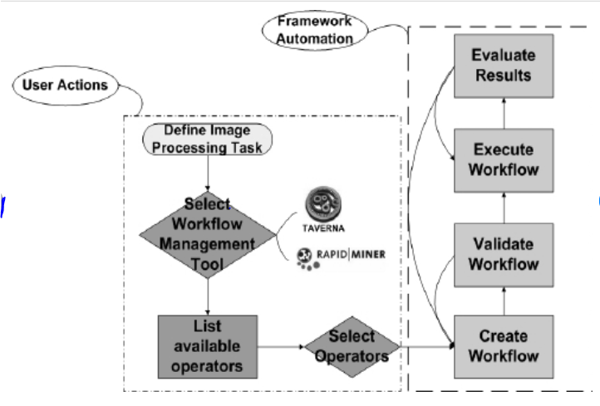

**DATA FLOW DIAGRAM**

# 5. Technologies to be used

## Software Platform

* Visual code
* Tensorflow
* Tensorflow lite
* Keras

## Hardware Platform

∙ i7-7500U

∙ 8GB VRAM

* GTX 1080 GPU

∙ Windows

# 6. Advantages of this Project

There are several advantages of image prediction of persons and objects, including:

1. Enhanced Security: Image prediction technology can be used for surveillance and security purposes. It can help to detect and prevent crimes, and monitor public places like airports, banks, and shopping malls.
2. Improved Medical Diagnosis: Image prediction can be used in the medical field to diagnose diseases and conditions. Medical professionals can use the technology to analyze X-rays, CT scans, and MRIs, and identify any abnormalities or diseases.
3. Efficient Marketing: Image prediction technology can be used for targeted advertising. Companies can analyze images of customers and their preferences to deliver personalized ads that are more likely to result in sales.
4. Improved Customer Service: Image prediction can be used to identify customers and their preferences, allowing companies to provide more personalized customer service. For example, if a customer walks into a store, the technology can analyze their image and identify their previous purchases or preferences, enabling the salesperson to offer tailored recommendations.

**7. Team Details**

| **Project Name & ID** | **Course Name** | **Student ID** | **Student Name** | **Role** | **Signature** |
| --- | --- | --- | --- | --- | --- |
| Image Prediction | Major project | TCA2056004 | Abhishek Kumar Shukla | Researcher, Tester And Developer |  |
| TCA2056008 | Deeksha Agarwal | Researcher and Tester. |  |
| TCA2056011 | Goldi Diwaker | Tester. |  |
|  |  | TCA2056016 | Nomaan Khan | Tester |  |

# 8. Conclusion

# We have successfully implemented VGG pre-trained models and predicted the image using it. I’ve merely given a general overview of the VGG pre-trained image categorization algorithms and how to use them. But because this is a constantly expanding field, there is always a fresh model to anticipate and new frontiers to explore. I implore you to test the models mentioned above on various datasets with various parameter settings and report your findings in the comments below!

# 9. References

<https://www.analyticsvidhya.com/blog/2022/09/image-prediction-using-a-pre-trained-model/>

<https://towardsdatascience.com/how-to-predict-an-image-with-keras-ca97d9cd4817>